Experiment No: 09
Experiment Name: Implementation of Deadlock Avoidance Using the Banker's Algorithm
Theory: Deadlock occurs when processes hold resources while waiting indefinitely for others held by different processes. The Banker's Algorithm, developed by Edsger Dijkstra, prevents deadlock by ensuring the system remains in a safe state before granting resource requests. It requires three matrices: Allocation (resources currently held), Max (maximum demand), and Need (remaining requirement, calculated as Need = Max − Allocation), along with an Available vector. A process can execute only if its Need does not exceed Available resources. Upon completion, it releases all allocated resources. The algorithm searches for a safe sequence where all processes finish; if found, the system avoids deadlock. This conservative approach prioritizes safety over resource utilization, making it suitable for multi-process environments where resource conflicts are predictable.
Code & Output:
Banker’s Algorithm:
- Input: Read the number of processes and resource types, then the Allocation matrix, the Max matrix, and the Available resources.
- Calculate Need: For every process and resource, Need = Max − Allocation. This is what each process still wants.
- Initialize: Mark every process as not finished and start with an empty safe sequence.
- Scan the processes: Go through each unfinished process and check whether its Need is less than or equal to Available for every resource type.
- Finish a process: If it fits, assume it runs to completion. Add its Allocation back to Available, mark it finished, and add it to the safe sequence.
- Repeat or stop:
- If a full pass finishes at least one process, scan again with the larger Available.
- If a full pass finishes none, print NOT safe and stop.
- If all processes are finished, print SAFE with the sequence.
The program takes process and resource counts, then reads Allocation, Max, and Available matrices. It calculates Need = Max − Allocation. Using a safety check loop, it finds processes whose Need can be met by Available resources. Each finished process releases its resources back to Available. If all processes complete, a safe sequence is printed; otherwise, deadlock is detected.

Code:
- # Banker's Algorithm

- def bankers_algo():
- n = int(input("Number of processes: "))
- r = int(input("Number of resource types: "))

- print("\n--- Allocation Matrix ---")
- alloc = []
- for i in range(n):
- row = list(map(int, input(f" P{i}: ").split()))
- alloc.append(row)

- print("\n--- Max Matrix ---")
- maximum = []
- for i in range(n):
- row = list(map(int, input(f" P{i}: ").split()))
- maximum.append(row)

- print("\n--- Available Resources ---")
- avail = list(map(int, input(" Enter: ").split()))

- # Need = Max - Allocation
- need = []
- for i in range(n):
- row = []
- for j in range(r):
- row.append(maximum[i][j] - alloc[i][j])
- need.append(row)

- finished = [False] * n
- safe_seq = []

- while len(safe_seq) < n:
- found = False

- for i in range(n):
- if finished[i]:
- continue

- # Flag: can process i run with the current avail?
- can_run = True
- for j in range(r):
- if need[i][j] > avail[j]:
- can_run = False
- break

- if can_run:
- # Process i finishes and releases its resources
- for j in range(r):
- avail[j] += alloc[i][j]
- safe_seq.append(i)
- finished[i] = True
- found = True

- if not found:
- print("\nSystem is NOT in a safe state", end='')
- print(" (deadlock possible).")
- return

- print("\nSystem is in a SAFE state.")
- print("Safe sequence: ", end='')
- print(" -> ".join(f"P{i}" for i in safe_seq))

- bankers_algo()

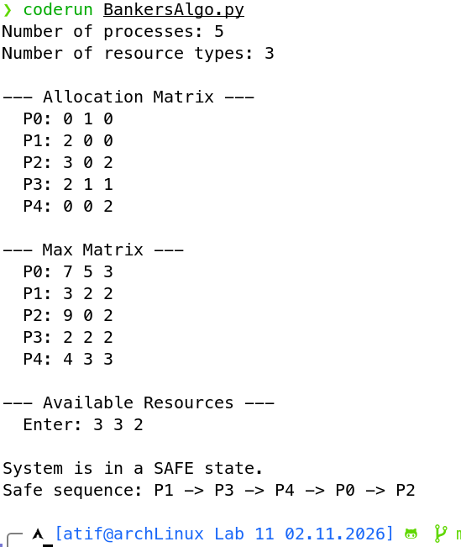

Fig: Banker’s Algorithm Implementation Output

Discussion:
This experiment implemented the Banker's Algorithm to detect safe states and prevent deadlock in resource allocation. By comparing Need against Available resources, the algorithm determined whether processes could execute without causing circular wait. The safety check iteratively found processes whose remaining demands could be satisfied, releasing their allocated resources upon completion to enable others. If all processes were sequenced successfully, the system was declared safe; otherwise, deadlock risk was identified. This conservative approach ensures system stability by only granting requests that maintain safety, though it may underutilize resources. Understanding such deadlock avoidance mechanisms is critical for designing reliable multi-process operating systems.

